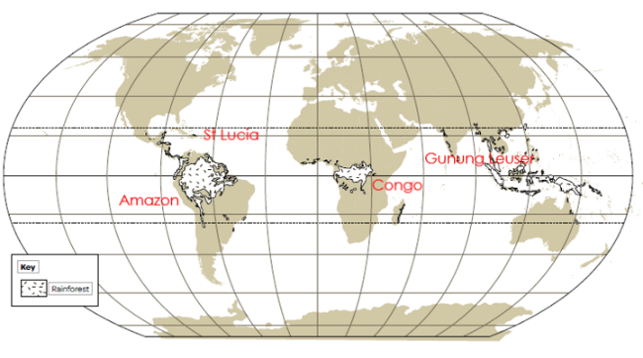

**Theme: The Anglo-Saxons**

**Subject areas covered:** pupils will learn about why they invaded and find out how we can possibly know where they settled? Children will also learn about King Alfred the Great and investigate just how great he really was. Saxon democracy and justice will be explored as will daily life including the life of a Saxon child. The archaeological site at Sutton Hoo will also be studied to enable pupils to build a better picture of Anglo-Saxon life and times. Further areas of study include how peoples lives changed when Christianity came to Britain and how the Viking threat was overcome.

**Theme: Science**

**Subject areas covered:** **Living Things and Their Habitats**

**As scientists,** we will recognise that living things can be grouped in a variety of ways. The children will explore and use classification keys to group, identify and name a variety of living things in their local and wider environment. They will recognise that environments can change and that this can sometimes pose dangers which have an impact on living things.

**As technicians,** the children will be building on their coding knowledge before learning how to use data-loggers effectively. These will be utilised throughout their school journey- particularly in Science lessons.

**Theme: Nutrition**

**Subject areas covered: DT**

As designers, the children will study food packaging to understand and assess its effectiveness. They will taste ingredients, design a pizza of their own and then create and eat their product. They will finally evaluate this and consider what they might do differently to improve their pizza- if they were to make it again.

**As theologians,** pupils will consider environmental elements including stewardship of the Earth, how different religions convey the treatment of animals, what the issues are with living in a disposable world and thinking about how to take care of the planet going forwards- despite the many various challenges that we face as humans.

School Value: Responsibility

**Key Information**

**Text focus:** Kenzuke’s Kingdom by Michael Morpurgo

**Writing Genres:** Character Change and Persuasion

**Maths:** Effective Maths

**Useful APPS:**

Timestablerockstars

Google Classroom

**PE:** Monday and Thursday

Reading books in every day.

**Homework:** in on Wednesday and given out Fridays.